**TASK MEMBUAT QUERY BAGIAN 2**

1. [SELECT](http://localhost/phpmyadmin/url.php?url=https://dev.mysql.com/doc/refman/8.0/en/select.html) * FROM `detail-transaksi` ORDER BY harga ASC;

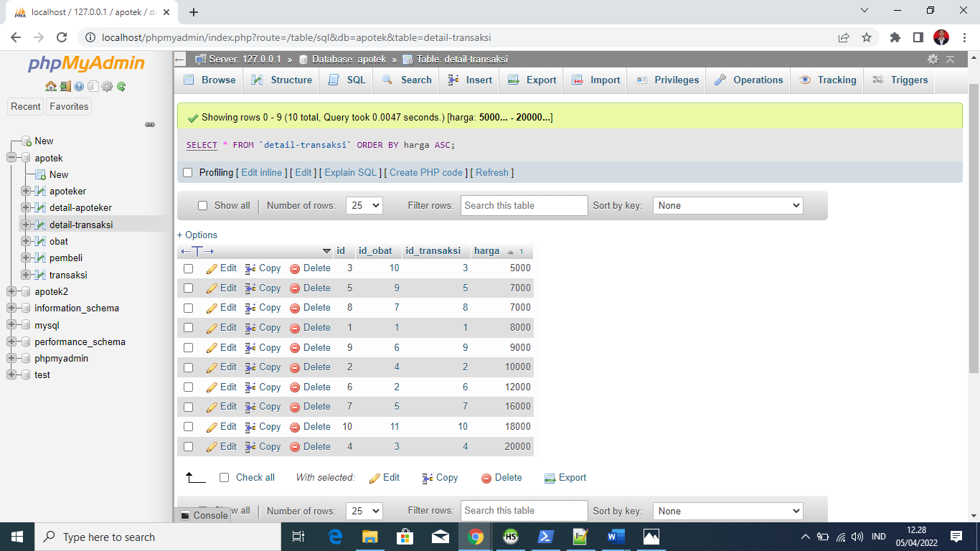

1. [SELECT](http://localhost/phpmyadmin/url.php?url=https://dev.mysql.com/doc/refman/8.0/en/select.html) * FROM `detail-transaksi` ORDER BY id_transaksi DESC;

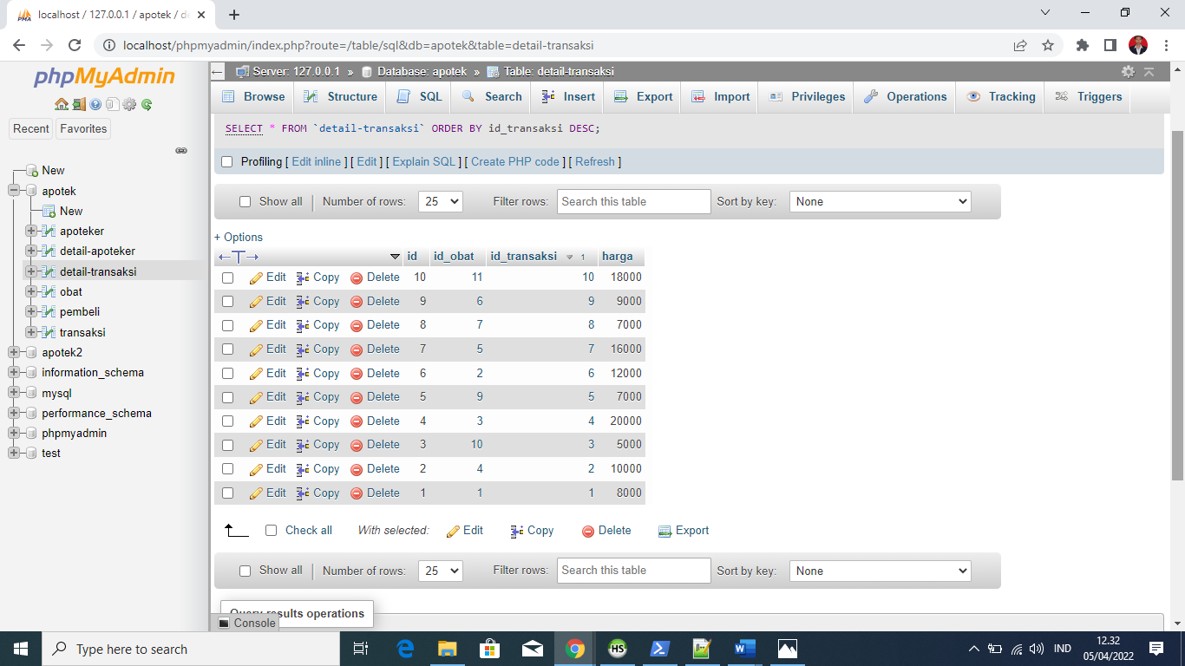

1. [SELECT](http://localhost/phpmyadmin/url.php?url=https://dev.mysql.com/doc/refman/8.0/en/select.html) * FROM `obat` WHERE jenis [LIKE](http://localhost/phpmyadmin/url.php?url=https://dev.mysql.com/doc/refman/8.0/en/string-comparison-functions.html%23operator_like) '%CSS%';

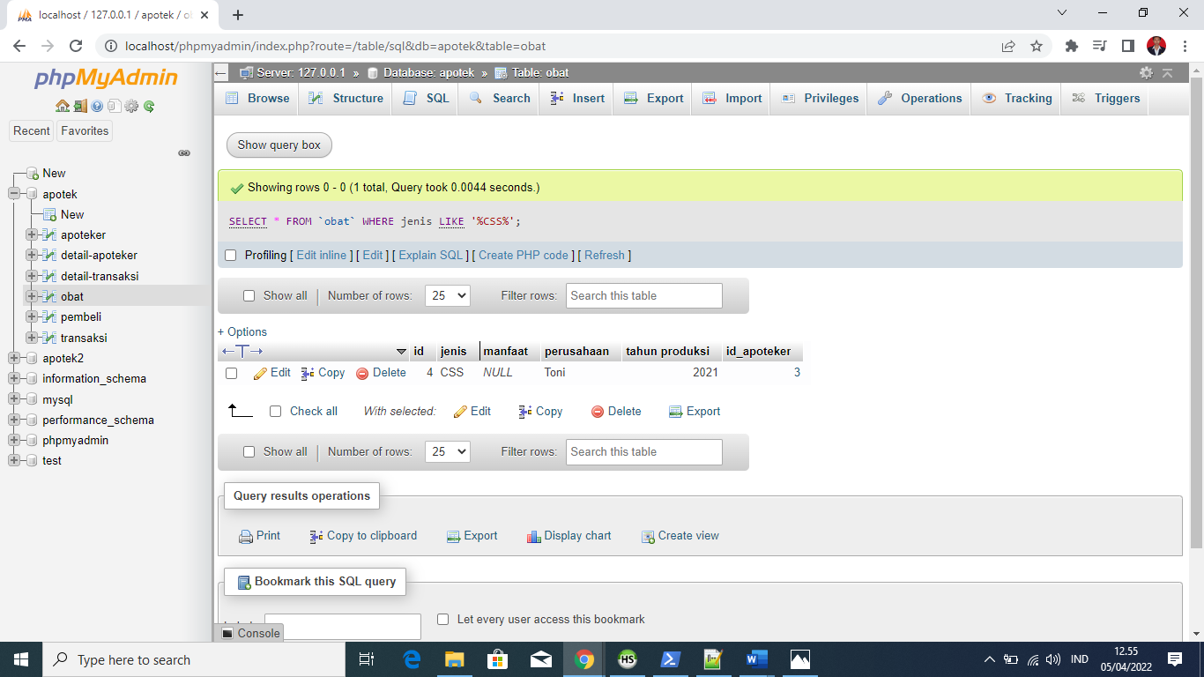

1. [SELECT](http://localhost/phpmyadmin/url.php?url=https://dev.mysql.com/doc/refman/8.0/en/select.html) * FROM `obat` WHERE jenis [LIKE](http://localhost/phpmyadmin/url.php?url=https://dev.mysql.com/doc/refman/8.0/en/string-comparison-functions.html%23operator_like) '%Laravel%';

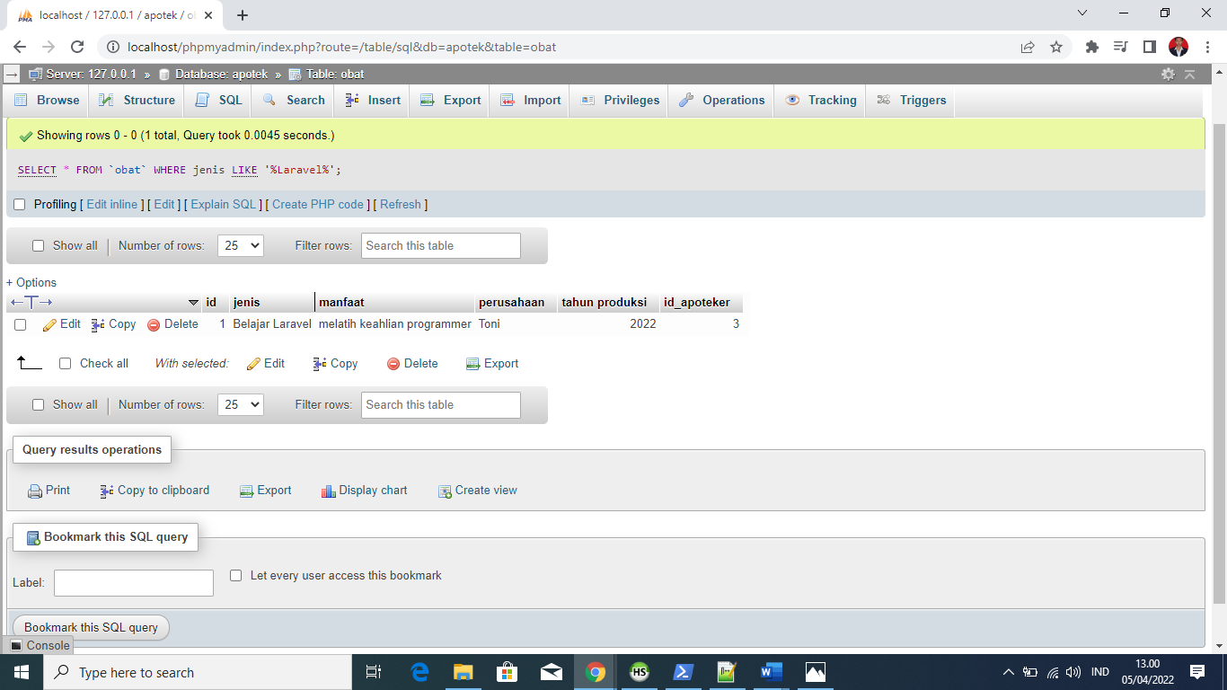

1. [SELECT](http://localhost/phpmyadmin/url.php?url=https://dev.mysql.com/doc/refman/8.0/en/select.html) id_transaksi, [SUM](http://localhost/phpmyadmin/url.php?url=https://dev.mysql.com/doc/refman/8.0/en/aggregate-functions.html%23function_sum)(harga) as total FROM `detail-transaksi` GROUP by id_transaksi;

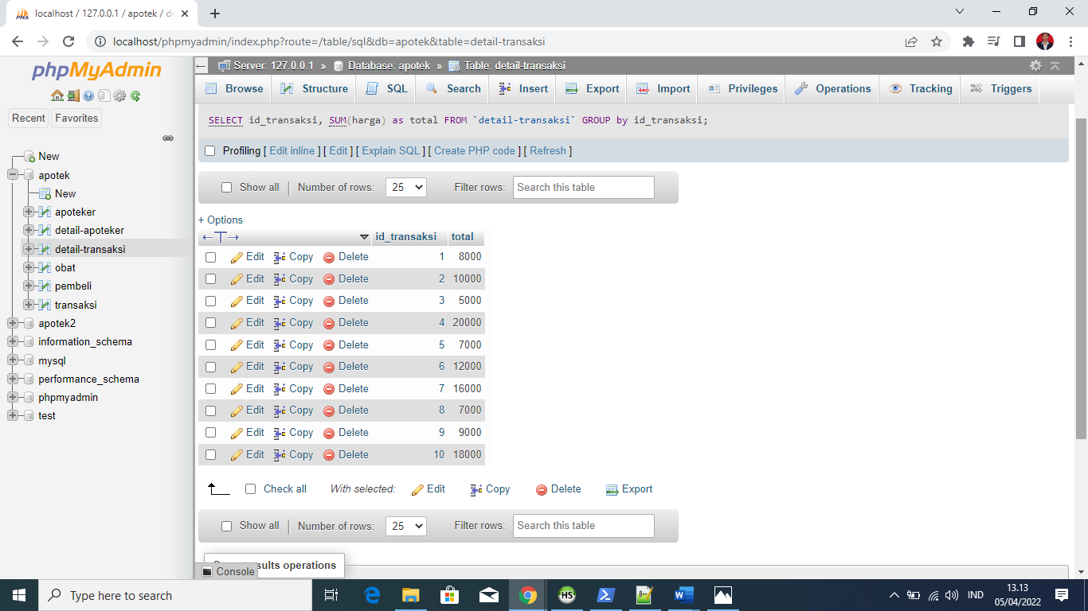

1. [SELECT](http://localhost/phpmyadmin/url.php?url=https://dev.mysql.com/doc/refman/8.0/en/select.html) id_obat, [SUM](http://localhost/phpmyadmin/url.php?url=https://dev.mysql.com/doc/refman/8.0/en/aggregate-functions.html%23function_sum)(harga) as total FROM `detail-transaksi` GROUP by id_obat;

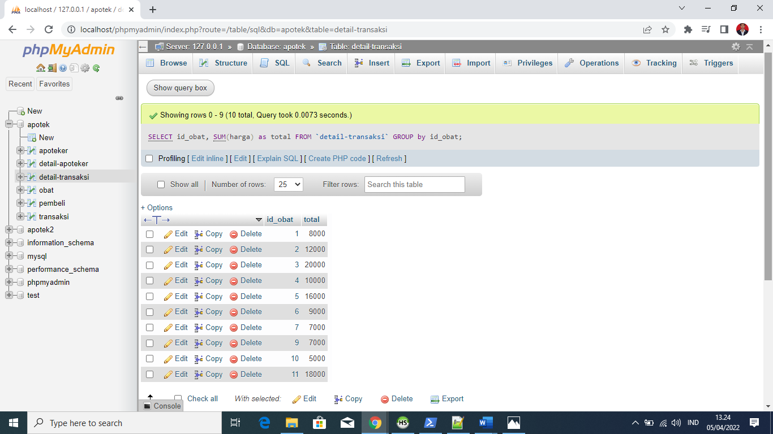

1. [SELECT](http://localhost/phpmyadmin/url.php?url=https://dev.mysql.com/doc/refman/8.0/en/select.html) id, [SUM](http://localhost/phpmyadmin/url.php?url=https://dev.mysql.com/doc/refman/8.0/en/aggregate-functions.html%23function_sum)(harga) as total FROM `detail-transaksi` GROUP by id;

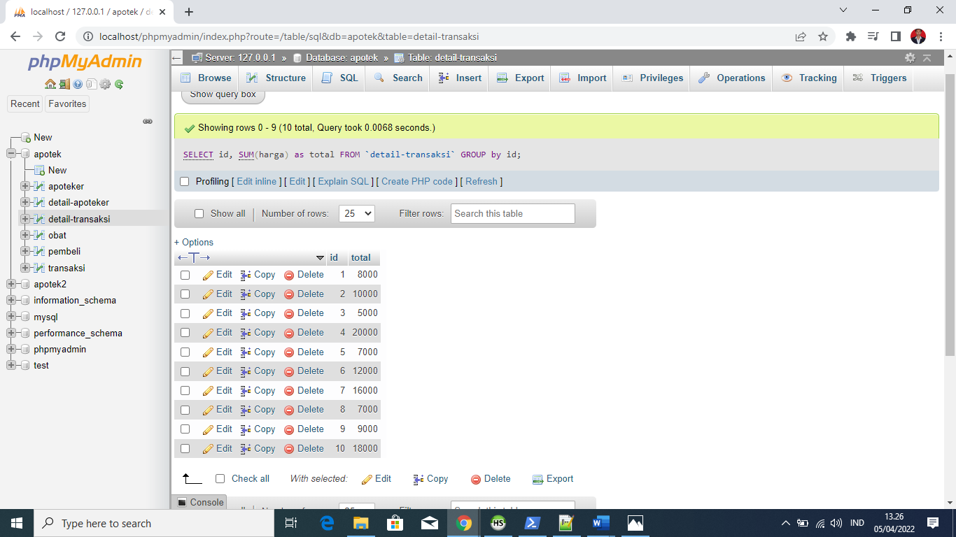

1. [SELECT](http://localhost/phpmyadmin/url.php?url=https://dev.mysql.com/doc/refman/8.0/en/select.html) id, [SUM](http://localhost/phpmyadmin/url.php?url=https://dev.mysql.com/doc/refman/8.0/en/aggregate-functions.html%23function_sum)(harga) as total FROM `detail-transaksi` WHERE id >1 GROUP BY id ORDER BY id DESC;

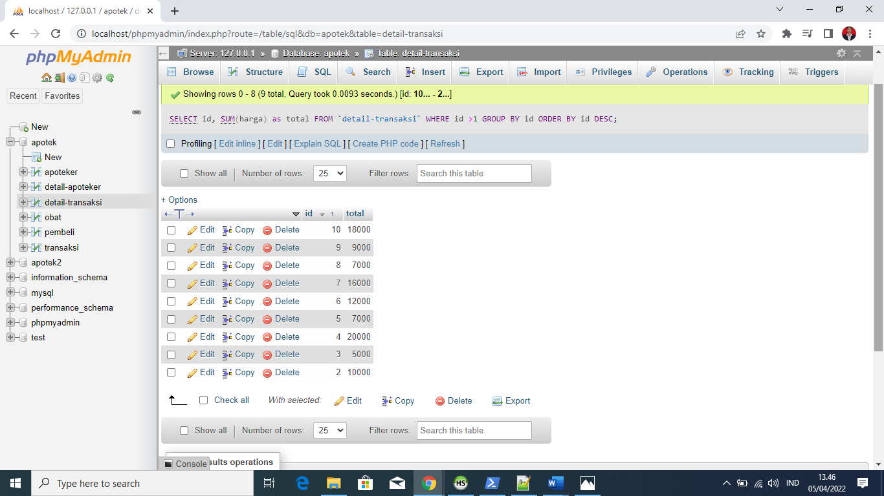

1. [SELECT](http://localhost/phpmyadmin/url.php?url=https://dev.mysql.com/doc/refman/8.0/en/select.html) id, [SUM](http://localhost/phpmyadmin/url.php?url=https://dev.mysql.com/doc/refman/8.0/en/aggregate-functions.html%23function_sum)(harga) as total FROM `detail-transaksi` WHERE id >5 GROUP BY id ORDER BY id ASC;

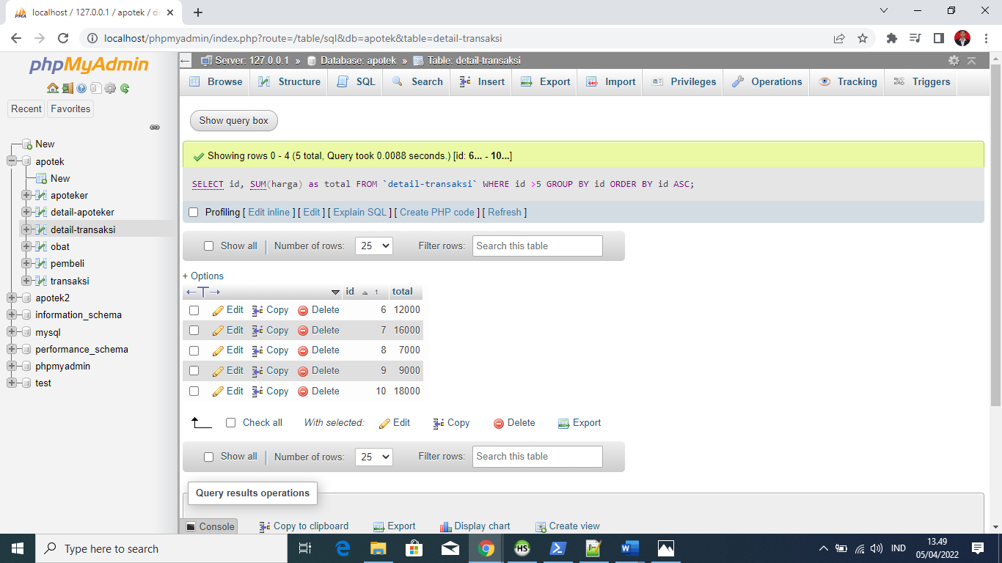

[SELECT](http://localhost/phpmyadmin/url.php?url=https://dev.mysql.com/doc/refman/8.0/en/select.html) id, [SUM](http://localhost/phpmyadmin/url.php?url=https://dev.mysql.com/doc/refman/8.0/en/aggregate-functions.html%23function_sum)(harga) as total FROM `detail-transaksi` GROUP BY id ORDER BY id ASC;

